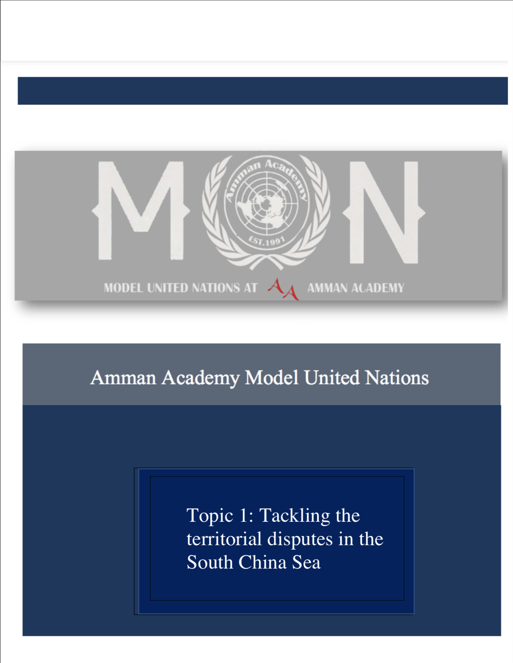

Topic 2: Addressing Turkey’s Weaponization of counter terrorism legislations against human rights defenders

**Introduction:**

Turkey has used counter-terrorism and national security measures to limit rights and freedoms and muzzle human rights defenders' perspectives.

A State of Emergency has been imposed in Turkey. Despite being officially repealed on July 19, 2018, this system was rendered permanent through a series of rules. The Anti-Terrorism Law No. 3713, which is utilized to fully limit rights and freedoms and silence the voices of human rights activists, is central to the government's approach. The law's overly wide and ambiguous terrorism definition allows for the labeling of nonviolent human rights campaigners as "terrorist offenders."

As a consequence, the number of inquiries and prosecutions has increased. According to official figures, 6551 persons were convicted under anti-terrorism legislation in 2020, while a whopping 208,833 were probed for "membership in an armed organization," including thousands of human rights defenders.

**Key Definitions:**

**Counterterrorism:** (sometimes written counter-terrorism) encompasses the procedures, military tactics, techniques, and strategies used by governments, law enforcement, business, and intelligence agencies to fight or eradicate terrorism. Counter-terrorism tactic is a government's main motivator to use country's power tools to neutralize and overcome terrorists, organizations, and networks in order to deliver them impossible of using evil to instill fear and coerce the government or citizens to react in accordance with these terrorists' goals.

**Human rights defenders:** Individuals who work alone or in groups to peacefully advance or defend human rights are referred to as "human rights defenders." That person can advocate for any human right (or rights) on behalf of other people or groups if they are a human rights defender. Advocates for human rights work to advance, safeguard, and realize economic, social, and cultural rights in addition to civil and political rights. Human rights defenders look into, compile data on, and document violations of human rights.

**The national security law:** Among other things, specified four specific crimes: secession, subversion, terrorism, and collusion with foreign organizations; any open speech, verbal promotion, and so on.

**General overview:**

Turkey uses the anti-terrorist argument to abandon international human rights standards in the cause of what they anticipated would be increased security against the threat of terrorism. Even twenty years after 9/11, the major negative events that weakened human rights are still prominent globally. These are: equating human rights defenders with terrorists; increased militarization leading to the strengthening of civil conflicts and a boost in breaches; the weakening of state-to-state peer influence as a method to affirm human rights; the propagation of exceptional laws that erode international law, particularly due to the vague and sweeping meaning of the word terrorism; and the negative global impact of US policy.

According to the administration, the term "terrorist" allows for a wide variety of coercive activities that are obviously illegal under international law. These tactics include limits on fundamental freedoms of assembly, association, and expression, which have rendered independent human rights activists a threatened species. Those who conform to onerous registration and operating requirements give up their independence, while those who try to avoid them face harsh penalties such as arbitrary detention, criminal prosecution, lengthy prison sentences, asset seizures, and travel bans, as well as being labeled as terrorists. Human rights activists have been persecuted and killed. As a result of these threats, a growing number of activists have gone into exile. Such measures have been enacted in order to suppress critics and hinder the work of individuals who want to improve human rights and hold governments responsible for their policies and practices.

Turkey contributed for one-third of the world's 35,000 terrorist convictions in the decade following 9/11. The startling numerical disparity in Turkey's terrorist prosecutions is due in part to its qualitative judgements of what constitutes terrorism. As then-Interior Minister Idris Naim Sahin declared in an infamous 2011 speech, Turkey is unusual in criminalizing numerous types of terrorism, including "artistic," "scientific," "poetic," and "journalistic." Erdogan officially supported the expansion of Turkey's anti-terrorism laws: "Whether they are a politician, academic, writer, journalist, or leader of a civil society organization, the reality that they are a terrorist does not alter."

The importance of creating a more unified conceptualization of the boundaries of terrorism and counterterrorism cannot be overstated, especially in light of the rise of social media and its potentially dangerous new interpretations of "spreading terrorist propaganda" and other indirect terror-related offenses. States of emergency also increase the freedom that countries have to deploy extremely dubious counterterrorism strategies due to the absence of a unified, globally recognized definition of "terrorism."

**Human rights impacted:**

* Freedom of association

Several international treaties, including the International Covenant on Civil and Political Rights (Article 22) and the European Convention on Human Rights, safeguard the right to freedom of association (Article 11). Restrictions on the right can only be imposed where they are mandated by law and are crucial in a democratic society in the interests of national security or public safety, the prevention of disorder or crime, the protection of health or morals, or the protection of others' rights and freedoms." Furthermore, all limits must be fair. In reality, this means that limits must be properly stated in legislation and must be the least rights restricting means of attaining their goal. Law No. 7262 was not written with enough accuracy and clarity. As a result, the Turkish government may use it as an excuse to limit human rights defender’s capacity to engage in their legal activities. It goes beyond the intended goal of preventing the financing of terrorists and poses a major risk of interfering with human rights groups' ability to exercise their right to freedom of association.

* Massive crackdown on human rights defense

Over the previous five years, Turkey's human rights situation has deteriorated dramatically. Counter-terrorism legislation and security measures have been purposefully exploited and misappropriated against civil society actors and human rights defenders in order to label them as "terrorists" and their legitimate activity as "separatist actions" or "threats to national security." Criminal prosecutions of human rights defenders and activists have generated an atmosphere of fear in Turkey, stifling the lawful activity of civil society organizations. The 11 human rights defenders in the Büyükada case mentioned above, as well as the prosecutions of 16 more activists beginning in 2019, including civil society leader Osman Kavala, are examples of blatant biased prosecutions. Law No. 7262 will only worsen this atmosphere of fear and further reduce the amount of room available for civil society actors such as human rights defenders to engage in productive activities.

* Restricting fundraising and freedom of expression

Online "unauthorized assistance collecting" is addressed in Article 7 of Law No. 7262. The legislation gives the Ministry of Interior or the appropriate governorship the authority to spot "unauthorized" fundraising operations online and to inform online service providers that the allegedly offensive content needs to be taken down within 24 hours. The Ministry requested that the content be blocked, and the court must make a decision within 24 hours. However, the statute specifically stipulates that no hearing will be held, so there is no chance for an association to speak with the judge immediately before the decision is made. The Information Technologies and Communication Authority will receive the judge's decision and take whatever unspecified "necessary action" is deemed necessary.

**Parties involved:**

**FATF:**

The FATF examined Turkey's adherence to the task force's 2019 assessment report, which determined that Turkey was only in "partial compliance" with the organization's recommendations regarding the funding of terrorism and possible vulnerabilities in the not-for-profit sector. "Implement a focused risk-based approach and proportional risk-mitigation measures to human rights defenders identified as at risk of terrorism financing abuse," was the FATF's advice to Turkey.

**Amnesty international:**

Amnesty International continues to play a significant role in this matter by interfering to promote the adoption of FATF. Without sufficient and effective judicial safeguards, the law contains provisions that permit the removal of board members and staff as well as the closure of organizations.

**The UN:**

The UN and the Special Rapporteurs urged the Turkish government to "immediately and unconditionally" free Ms. Finance and any other members of civil society who had been detained. Additionally, they fought for access to fundamental protections and the preservation of defenders' physical and emotional health both inside and outside of detention. As a further method of generating awareness and a means of expressing its opinions on the issue, the UN continued to create reports and published the case on UN News. In addition, resolutions adopted by the UNSC on this topic imply that nations must ensure that all counterterrorism measures, particularly those directed at terrorism financing, uphold their obligations under international human rights law.

**Timeline:**

**1983:**

A group of attorneys in Izmir established the Human Rights Agenda Association (IHGD) in 1983.

Minority rights and international criminology are the key areas of emphasis.

**1986:**

Several intellectuals daring the 1980–87 and the country “state of emergency”; created the IHD in 1986. (1987-90). The association was accused of being pro-Kurdish and pro-PKK by groups and the mainstream media due to the growing attention on egregious human rights violations in the context of the Kurdish war.

Side note: IHD traditionally focuses on issues such as the state of prisons, abductions, illegal killings, including political ones, torture, and the freedom of expression and peaceful assembly.

**2003:**

Despite the associations independence from political parties, DEHAP, a left-wing Kurdish

Coalition, nominated Akn Birdal and Yusuf Alatas as candidates for the 2002 parliamentary

elections. They are currently the general chairs of the IHD.

**2004:**

Professor Ioanna Kucuradi has been involved in human rights advocacy since the late 1970s

And works with the major human rights NGOs. She was the head of the now-defunct National

Committee for Human Rights Education and was kicked from the Human Rights Advisory

Council in 2004, along with Professors Baskn Oran, Ibrahim Kaboglu, and other independent

Academics.

**2005:**

-The Turkish Medical Association, Health Labor Union, and Association for the Rights of Medical

Patient’s leaders have been charged with planning a rally for the universal right to health. **In April**

**2005**, 85 suspects were acquitted.

-**In July 2005**, Adalet Agaoglu, a notable author, resigned from the IHD, accusing it of not being

Sufficiently critical of the PKK and of stressing human rights atrocities against the Kurdish

People.

-**In April 2005**, Turkish Revenge Brigades, a paramilitary outfit suspected to be funded by

Unknown members in the gendarmerie forces and Mafia networks affiliated with the Nationalist

Action Party (MHP), were threatening Istanbul IHD leaders.

-Huseyin Aygun, former chair of Tunceli Bar Association and proprietor of a local newspaper,

Alleged in **February 2005** that a gendarmerie commander threatened him with murder for human

Rights monitoring and advocacy activities he was involved in. He is being charged for insulting

The commander in respect to this comments.

-Rdvan Kzgn, Bingol IHD member, was sentenced to two and a half years in jail on **December 1,**

**2005**, in relation to a fact-finding report produced in 2003, which accused the gendarmerie of

Violating the right to life. The gendarmerie repeatedly pressed Kzgn to retract the report.

-By **the end of 2005**, there were hundreds of charges filed against the IHD in connection with

Their press releases and human rights reports.

**2022:**

Ms. Finance, who worked on the Istanbul Protocol, a set of UN reference standards for the investigation and documentation of allegations of torture, was detained on October 26. Her detention is thought to be punishment for publicly demanding investigations into the alleged use of chemical weapons and the deaths that followed involving Turkish military personnel. Dr. Finance’s detention, however, seems to be a purposeful attempt to use counter-terrorism laws against human rights advocates and organizations in order to undermine and obstruct their essential medical and human rights work.

**Past solutions:**

**-**Pertinent UNSC Resolutions and FATF recommendations were passed, they indicate that states are required to make sure that all counterterrorism efforts, including those aimed at terrorism financing, adhere to their responsibilities under international human rights law, including upholding basic freedoms like the right to free speech and the right to association.

-The International Covenant on Civil and Political Rights, which forbids arbitrary arrest or imprisonment, was ratified by Turkey in 2003.

-By signing on to the UN Convention against Torture and Other Cruel, Inhuman, or Degrading Treatment or Punishment in 1988, Turkey agreed to abide by a set of international standards that prohibit torturing those who defend human rights.

**Possible solutions:**

-Make sure the Turkish government adheres fully with recommendations 8 and 1 of the FATF to prevent inadequately and excessive actions against the human rights sector that would breach Turkey's commitments under international human rights law.

-Have a conversation with Turkish authorities to determine which parts of Law No. 7262 are in contravention of Turkey's duties under international human rights law, such as the freedoms of association and expression and the right to a fair trial.

-Demand that the Turkish government to amend the specific sections of the new law that would impermissibly restrict freedoms of association and expression, including restrictions on online fundraising activities.

- Demand that the Turkish government amend its anti-terrorism laws to comply with international human rights law and standards in order to prevent harassment against human rights defenders.

**References:**

Hicks, Neil. “Views: The Impact of Counter-Terrorism Measures on Human Rights in the Middle East and North Africa - رواق عربي: Rowaq Arabi.” *رواق عربي | ROWAQ ARABI*, 9 Aug. 2022, rowaq.cihrs.org/views-the-impact-of-counter-terrorism-measures-on-human-rights-in-the-middle-east-and-north-africa/?lang=en&=1.

“How Turkey Weaponizes Counter-Terrorism Legislation against Human...” *OMCT*, 1 Jan. 1970, [www.omct.org/en/resources/reports/turkey-the-instrumentalization-of-the-counter-terrorism-legislation-and-policies-and-their-impact-on-hrds](http://www.omct.org/en/resources/reports/turkey-the-instrumentalization-of-the-counter-terrorism-legislation-and-policies-and-their-impact-on-hrds).

“Turkey: Human Rights Defender on Trial.” *Human Rights Watch*, 21 Feb. 2022, [www.hrw.org/news/2022/02/21/turkey-human-rights-defender-trial](http://www.hrw.org/news/2022/02/21/turkey-human-rights-defender-trial).

*TURKEY: WEAPONIZING COUNTERTERRORISM*. [www.amnesty.org/en/wp-content/uploads/2021/07/EUR4442692021ENGLISH.pdf](http://www.amnesty.org/en/wp-content/uploads/2021/07/EUR4442692021ENGLISH.pdf).

“Türkiye: UN Experts Call for End to Harassment of Human Rights Defenders | | 1UN News.” *United Nations*, United Nations, news.un.org/en/story/2022/11/1130352.